SEPTEMBER 14, 2014, BIG KNIFE PROVINCIAL PARK OUTING

The Buffalo Lake Naturalist and Camrose Outdoor Clubs have an annual outing to Big Knife. Some arrived on Saturday and stayed overnight and enjoyed canoeing while others arrived in time for lunch at 12 noon on Sunday and the hike at 1 PM. Those attending were Elizabeth and Kurt Bagdan, Brian Biggs, Ann Bird, Charley Bird (hike leader), Mark Higgins, Scott, Wayne Kinsella, Claudia Lipski, Mary Roy, Sharon Stuart and Patricia Wood. The following picture is of the group at the start of the hike.

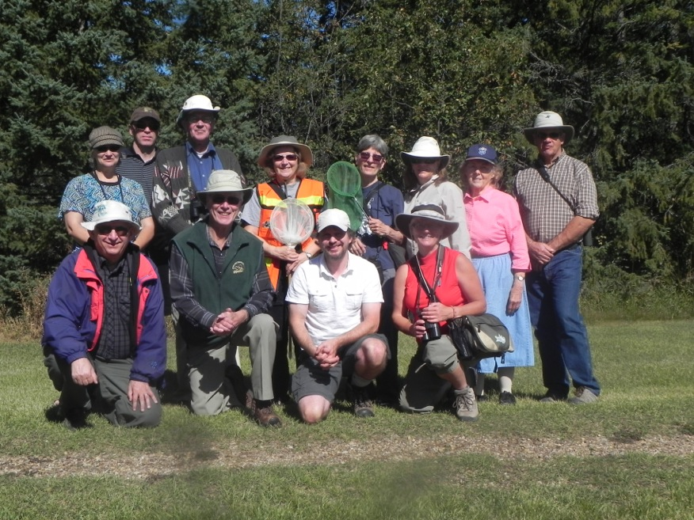

The weather was warm and sunny. The fall colors were gorgeous. In the past, we had walked the Lowland Trail, this time we hiked the Upland Trail. We saw five Turkey Vultures, one of which had a band, soaring overhead. Highbush Cranberries, Chokecherries and Hawthorns were shrubs that were in fruit. Scott talked about piles of mammal “poop” that we found on the trail. We looked for mushrooms and saw two kinds of puffballs and two other species. Butterflies seen were lots of Clouded Sulphurs, some Western Checkered Whites, a few Cabbage Butterflies, a Mourning Cloak, a Milbert’s Tortoiseshell and a Melissa Blue. Two species of Dragonflies were seen. Claudia Lipski mentioned hearing a small flock of White-fronted Geese flying over. After the hike was over, at 5 PM, Claudia and Scott saw 30 Turkey Vultures soaring overhead. Claudia later reported the Turkey Vulture sightings to Wayne Nelson who is studying their nesting success and distribution in Alberta.

