6 July 2014 DRY ISLAND BUTTERFLY COUNT

Location: Dry Island Buffalo Jump Provincial Park, Red Deer River Valley, east of Huxley.

Folks gathered at the Upper Viewpoint/Parking Lot and the Count started at 10 AM. Five species of butterflies were seen in that area. After an introductions and a short talk, we drove down to the picnic area. We had scattered cloud with a light NW wind throughout the Count and the temperature ranged from 20-26 C. We roamed around the picnic area, then had lunch at noon. After that we had a discussion period where various participants talked about the importance of the Park, and various natural history topics. After lunch, because of the large number of participants, we divided up into three teams, one lead by John Acorn, one by David Lawrie and Vic Romanyshyn, and one by Charley Bird, while a small group watched near the picnic tables. Wildflowers were in abundance. Mosquitoes were seldom a problem. Kilometers on foot estimated to be over 10. This count has been held annually since 1999.

The participants (41) were Ben Acorn, John Acorn, Curt Bagdan, Elizabeth Bagdan, Gerry Bennett, Judy Bennett, Ann Bird, Charley Bird (Compiler), Tony Blake, Shannon Brown, Wayne Brown, Les Dobos, Don Easton, Rhonda Easton, Pat Edgerton-McGhan, Bernice Hafner, Gail Hughes, Debra Jungling, Margot Jungling, Trudy Kolpean (Park Ranger), David Lawrie, Claudia Lipski, Dermot MacDougall, Iain MacDougall, Rhonda Mackay, Jim McCabe, Christie Mason, Joan Meeres, Myrna Pearman, Cynthia Pohl, Colleen Raymond, Vic Romanyshyn, Mary Roy, Tim Schowalter, Bob Schreiber, Robin Tarnowetzki (Reporter, Stettler Independent), Brooklyn Vale, Jayden Vale, Keaton Vale, Sheila Vale, and Kory Wall.

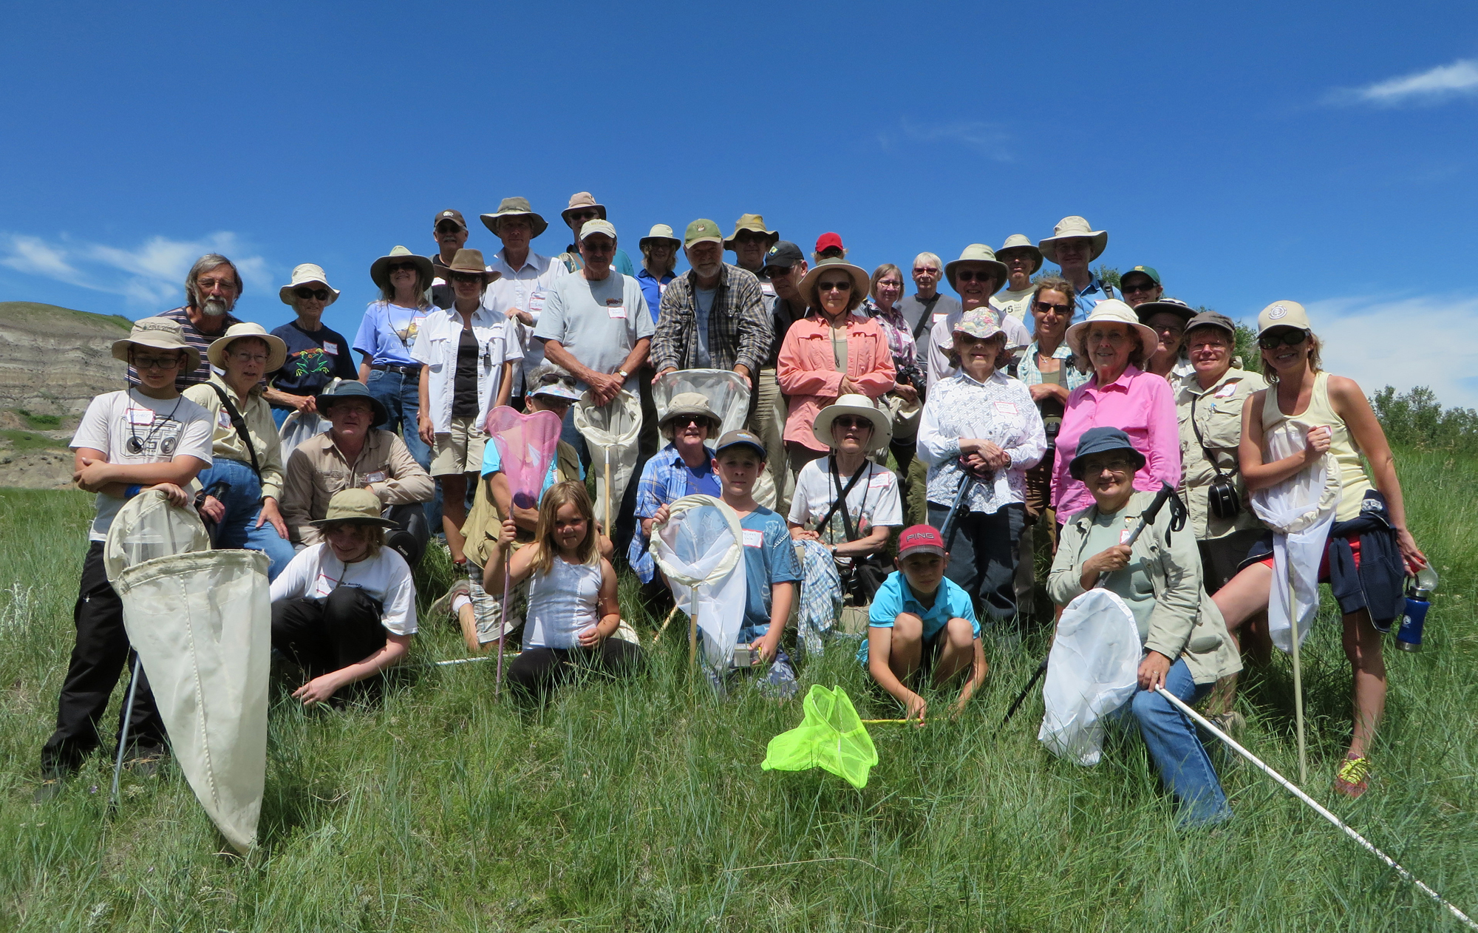
Participants in the 2014 Dry Island Butterfly Count

SPECIES OBSERVED – The names and order follow that of G.R. Pohl et al., 2010, An Annotated List of the Lepidoptera of Alberta, Canada (ZooKeys 38, 1-549, Special Issue).

Pyrgus communis (Checkered Skipper) – 10
Oarisma garita (Garita Skipper) – 10
Polites themistocles (Tawny-edged Skipper) – 6
Polites mystic (Long Dash Skipper) – 4
Euphyes vestris (Dun Skipper) - 1
Papilio machaon dodi (Dod’s Old World Swallowtail – 10
Papilio canadensis (Canadian Tiger Swallowtail) – 3
Colias philodice (Clouded Sulphur) – 7
Colias alexandra christina (Christina Sulphur) – 1
Pieris rapae (Cabbage Butterfly) - 1
Pontia (Pieris) occidentalis (Western Checkered White) – 6
Lycaena hyllus (Bronze Copper) – 2
Everes amyntula (Western Tailed Blue) - 5
Glaucopsyche lygdamus (Silvery Blue) – 15
Plebejus (Lycaeides) melissa (Melissa Blue) – 11
Icaricia shasta (Shasta Blue) – 10
Aricia (Plebejus) saepiolus (Greenish Blue) – 19
Basilarchia arthemis (White Admiral) – 17
Speyeria cybele pseudocarpenteri (Great Spangled Fritillary) – 3
Speyeria aphrodite (Aphrodite Fritillary) – 1
Speyeria hesperis (atlantis lais) (Northwestern Fritillary) – 4
Speyeria callippe (Callippe Fritillary) - 1
Phyciodes batesii (Tawny Crescent) – 12
Phyciodes cocyta (Northern Crescent) – 11
Phyciodes spp. – 20
Coenonympha inornata benjamini (Common Ringlet) - 24

Two dragonflies were observed: Ophiogomphus severus (Pale Snaketail) and Aeschna interrupta (Variable Darner). One damselfly was noticed: Enallagma annexum (cyathigerum) (Northern Bluet).

General Comments: An excellent turnout with 41 observers. Twenty-five species of skippers and butterflies and 214 individuals were seen. Two species, Lycaena hyllus (Bronze Copper), netted by Shannon Brown and Christie Mason; and Euphyes vestris (Dun Skipper), netted by David Lawrie, had not been seen on any of the previous counts. The latter is the second record of the species from Alberta, the first having been made near Erskine y the compiler on July 20, 1999. One species, Speyeria callippe (Callippe Fritillary), netted by Tim Schowalter, had only been recorded once before on a Dry Island Count. Many participants had nets. The Count being in a Provincial Park, was catch, identify and release. All agreed that this Park is one of the most beautiful in Alberta and all hoped that, with continued good management, it will remain so. Lots of scenery and flower photos were taken.

There was an abundance of wildflowers in bloom. The flight times of butterflies often corresponds with the flowering times of various plants, therefore, notes were kept of the plants that were seen in flower (Gail Hughes is thanked for her help in compiling this list). These included: Achillea millefolium (Yarrow), Anemone canadensis (Canada Anemone), Astragalus canadensis (Canada Milk-vetch), Campanula rotundifolia (Harebell), Astragalus bisulcatus (2-grooved Milkvetch), Astragalus goniatus (Purple Milkvetch), Bouteloua gracilis (Blue Grama Grass), Bromus inermis (Awnless Brome), Cornus stolonifera (Red Osier Dogwood), Eriogonum flavum (Yellow Umbrella-plant), Gaillardia aristata (Brown-eyed Susan), Galium boreale (Northern Bedstraw), Gaura coccinea (Scarlet Butterflyweed), Geum allepicum (Yellow Avens), Guttierezia sarothrae (Broomweed), , Hymenoxys richardsonii (Colorado Rubber-plant), Lilium philadelphicum (Western Wood Lily), Linum lewisii (Wild Blue Flax), Linum rigidum (Yellow Flax), Melilotus alba (White Sweet-clover), M. officinalis (Yellow Sweet-clover), Monarda fistulosa (Wild Bergamot), Opuntia polyacantha (Prickly-pear Cactus), Penstemon gracilis (Lilac-flowered Beardtongue), Penstemon procerus (Slender Beardtongue), Petalostemon purpureum (Purple Prairie-clover), Potentilla anserina (Silverweed), Potentilla arguta (White Cinquefoil), Potentilla fruticosa (Shrubby Cinquefoil), Potentilla gracilis (Graceful Potentilla), Psoralea esculenta (Indian Bread-root), Rosa acicularis (Prickly Rose), Rosa arkansana (Prairie Rose), Senecio canus (Silvery Groundsel), Sisyrinchium montanum (Blue-eyed Grass), Sphaeralcea coccinea (Scarlet Mallow), Stellaria longifolia (Long-leaved Chickweed), Symphoricarpos occidentalis (Buckbrush), Taraxacum officinale (Common Dandelion), Thalictrum venulosum (Meadow Rue), Tragopogon dubius (Goat’s-beard), Vicia americana (Wild Vetch), Vicia cracca (Tufted Vetch) and Viola canadensis (Canada Violet).

Charles Bird

